2011
COMMENTS or QUESTIONS ABOUT T-117

(attach additional pages as needed)
Name
Address
City, State, Zip

To submit comments or questions, you can:
- Mail this form or your written comments to:
Kendra Tyler, Public Involvement Coordinator
U.S. EPA Region 10, 1200 Sixth Avenue, Suite 900, Seattle, WA 98101
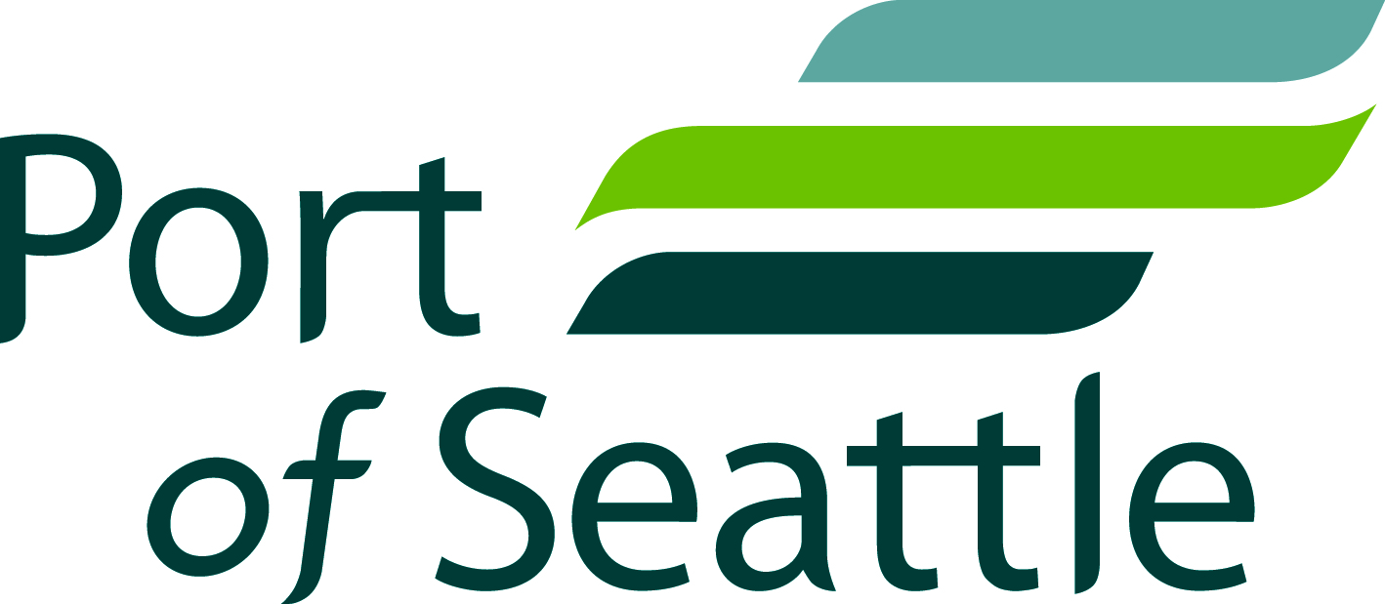
- Email your comments to tyler.kendra@epa.gov

